COLLEGE OF TECHNOLOGY AND ENGINEERING

**MAHARANA PRATAP UNIVERSITY OF AGRICULTURE & TECHNOLOGY**

## UDAIPUR (RAJ.)



**A**

**PROJECT REPORT**

**ON**

DateYourEve: Connecting People

(Event Management System)

submitted in partial fulfillment for the award of the Degree of Bachelor of Technology in Department of Computer Science & Engineering

(Session 2020-2021)

**Submitted By:**

**Asha Dangi**

**B.Tech. Final Year**

**Computer Science & Engineering**

**Hritik Kumar Sharma**

**B.Tech. Final Year**

**Computer Science & Engineering**

**Manas Singh**

**B.Tech. Final Year**

**Computer Science & Engineering**

# ACKNOWLEDGEMENT

Completing a task is never a one-man effort. It is often the result of valuable contribution of a number of individuals in a direct or indirect manner that helps in shaping and achieving an objective. It is very difficult for anyone to complete a project without the active cooperation and the benefit of advice from people who are experts in their field of specialization. The satisfaction and euphoria that accompanies the successful completion of any task would not be complete without the mention of people who made it possible.

With due honour, we want to thank all the personalities who made us able to do this interesting work. First of all, we would like to thank CTAE Udaipur for giving us the opportunity to carry out this minor project in their esteemed institution.

We are grateful to our honourable faculty who provided us all the facility.

**Asha Dangi**

**Hritik Kumar Sharma**

**Manas Singh**

# DECLARATION

We hereby declare that the project work entitled **“EVENT MANAGEMENT SYSTEM”** submitted to the CTAE Udaipur, is a record of an original work done by us under the guidance of Ms. DIKSHA GOYAL Asst. Professor Dept. of Computer Science and Engineering, College of Technology And Engineering, and this project work is submitted in the fulfilment of the requirements for the practical of Mobile Application Development. The results embodied in this report have not been previously submitted to any other University or Institute.

**Date:** **18/12/2020**

**Place:** **Udaipur**

## Asha Dangi

**Hritik Kumar Sharma**

**Manas Singh**

## Contents

ACKNOWLEDGEMENT i

DECLARATION ii

LIST OF TABLES v

LIST OF FIGURES vi

ABBREVIATION vii

ABSTRACT viii

1. INTRODUCTION 1
   1. INTRODUCTION TO ANDROID 2
   2. EVENT MANAGEMENT SYSTEM 2
   3. BACKGROUND OF STUDY 3
   4. APPLICATION 3
2. PROBLEM STATEMENT 4
   1. PROBLEM STATEMENT 5
3. REQUIREMENT ANALYSIS 6
   1. FUNCTIONAL REQUIREMENTS 7
   2. NON-FUNCTIONAL REQUIREMENTS 7
   3. SYSTEM CONFIGURATION 7
   4. SOFTWARE REQUIRED 7
   5. COMPATIBILITY 7
4. SYSTEM ANALYSIS 8
   1. CLASS DIAGRAM OF CURRENT SYSTEM 9
5. IMPLEMENTATION 10
   1. SYSTEM DESIGN 11
   2. DATABASE IMPLEMENTATION 15
   3. CODING DETAILS 16
   4. TESTING 19
      1. COMPONENT TESTING 19
      2. SYSTEM TESTING 20

CONCLUSION & FUTURE WORK 21

REFERENCES 23

# LIST OF TABLES

TABLE 1: COMPONENT TESTING……………………………………………………**19**

TABLE 2: SYSTEM TESTING………………………………………………………….**20**

# LIST OF FIGURES

FIGURE 1: CLASS DIAGRAM OF SYSTEM IMPLEMENTATION **9**

FIGURE 2: LOGIN/OTP SCREEN **11**

FIGURE 3: HOME MODULE **12**

FIGURE 4: SEARCH MODULE **12**

FIGURE 5: CREATE EVENT MODULE **13**

FIGURE 6: NOTIFICATIONS MODULE **13**

FIGURE 7: PROFILE MODULE **14**

FIGURE 8: INTERNAL DATABASE SCHEMA **15**

FIGURE 9(a): CODE SNIPPET OF LOGIN SCREEN **16**

FIGURE 9(b): CODE SNIPPET OF HOME MODULE **16**

FIGURE 9(c): CODE SNIPPET OF SEARCH MODULE **17**

FIGURE 9(d): CODE SNIPPET OF CREATE EVENT MODULE **17**

FIGURE 9(e): CODE SNIPPET OF NOTIFICATIONS MODULE **18**

FIGURE 9(f): CODE SNIPPET OF PROFILE MODULE **18**

# ABBREVIATION

CTAE - COLLEGE OF TECHNOLOGY AND ENGINEERING

DFD - DATA FLOW DIAGRAM

DYE – DATE YOUR EVE

SYSTEM SQA - SOFTWARE QUALITY

XML - EXTENSIBLE MARKUP LANGUAGE

NoSQL – NO STRUCTURED QUERY LANGUAGE

# ABSTRACT

Nowadays, Event Management System is one of the most essential tools that are mostly used in Event planning in India.

Event Management is a strong and fast-growing profession with a rather low level of standardization. Often, we take Event Management as a part of project Management, but we have to consider that Event Management has very specific concepts and issues, and needs further developed methods and tools. We classify Events, we compare Project Management and Event Management, we reconsider standards in both areas, and discuss perspectives for a stronger standardization of Event Management in the future.

In this project we developed an Android based Event Management System. Our main intention is to allow this application to be used in organizing Events and registration of Events.

Event Management System has its own significance to the social gathering in India. Using this System, it will help us to create Events and book a seat in those Events.

## Chapter-1

**INTRODUCTION**

## Introduction to Android

Android is a Linux based operating System it is designed primarily for touch screen mobile devices such as smart phones and tablet computers. The operating System has developed a lot in last 15 years starting from black and white phones to recent smart phones or mini computers. One of the most widely used mobile OS these days is android. The android is software that was founded in Palo Alto of California in 2003.

The android is a powerful operating System and it supports large number of applications in Smartphones. These applications are more comfortable and advanced for the users.

The android development supports with the full java programming language. Even other packages that are API and JSE are not supported. The first version 1.0 of android development kit (SDK) was released in 2008 and latest updated version is jelly bean.[1]

## Event Management System

This project is concerned about developing an Event Management System that will be used for Event Management. User can create events which can be seen by all the users of our application and also every user can search Events on the basis of Event Name. Whenever a user will create an Event, he will be notified in notification section. User can also maintain a profile in which he/she can have Name, Gender, Bio and Location. He/She can also add a profile photo. They can also edit their profile.

## Background of Study

Due to the size and quality service of the Event services, the Event Management System has a very large customer base. These customers tend to visit the Event Management System for services mostly when they choose Event online.

Now a days in this COVID pandemic situation people are not able to book offline registration of the Event and also, they want a very smooth process in registration of events. People are not able to find out the right events near around them and also based on their preferences.

## Application

This application can be used by anyone like ranging from a student to a professional. Anyone needs a smartphone and Internet connectivity in order to use this application. The application can be used to create events, and also maintain a public profile. User can search events around his location or based on the event name.

## Chapter-2

**PROBLEM STATEMENT**

## Problem Statement

Improving performance and efficiency in Event Management System is a major goal. The application can be used to create events, and also maintain a public profile. User can search events around his location or based on the event name.

The application will provide quick access to the events maintained and user will be able to track events around him.

The following are among of the problems that lead to propose creation and development of Event Management System Software:

* + - There is no effective management of information
    - Discrepancies of Event Details.
    - It’s hard to determine Event Entry Fee.

## Chapter-3

**REQUIREMENT ANALYSIS**

## Functional Requirements

There are functions done by the System such as: Creating Events, Searching Events, Notifications about new Events, Profile data.

## Non-Functional Requirements

Event Management System is able to operate in the following characteristics:

* + - Any familiar in using Android operation can operate the System since it has user friendly and easy to use user interface.
    - Reliability: The Event Management System is available based on the user needs, user can create Events and also search Events. The Event Management System is password protected to change things on the System.

## System Configuration

* + - Minimum 8GB RAM for running Android Studio
    - 2GB of Graphic card
    - 5GB of available disk space (10GB Recommended)

## Software Required

* + - Android Studio 4.1.1(64-bit)
    - JAVA Installed (JRE 1.8.0_202 installed)
    - Gradle 6.0.1

## Compatibility

* + - Minimum SDK version 19
    - Target SDK version 26
    - Android Version 4.1 (Jelly Bean) and above

## Chapter-4

**SYSTEM ANALYSIS**

**System Analysis**

It is a process of collecting factual data, understand the processes involved, identifying problems and recommending feasible suggestions for improving the System functioning. This involves studying the business processes, gathering operational data, understand the information flow, finding out bottlenecks and evolving solutions for overcoming the weaknesses of the System so as to achieve the organizational goals. System Analysis also includes subdividing of complex process involving the entire System, identification of data store and manual processes.

## Class diagram of How System is Implemented

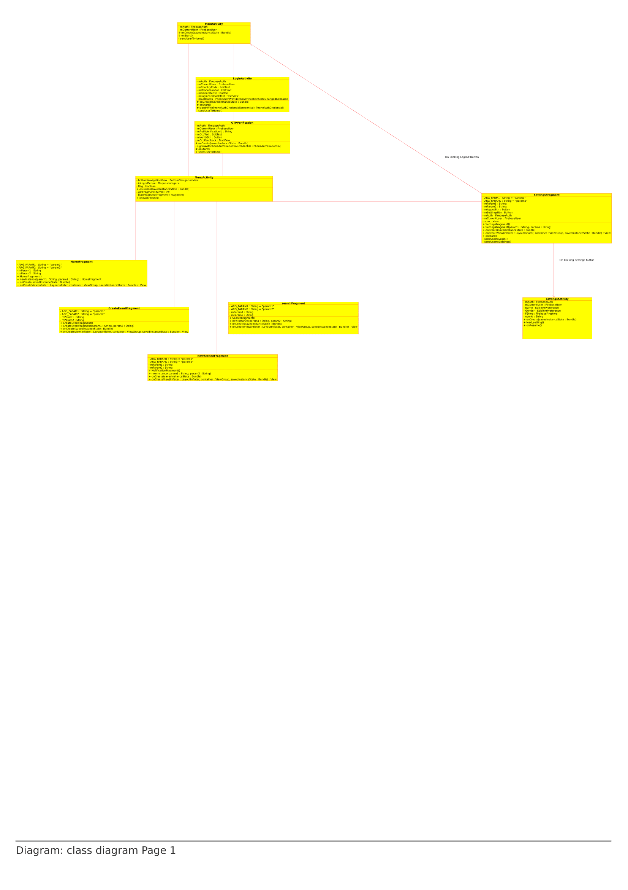

Figure 1: Class Diagram of System Implementation

## Chapter-5

**IMPLEMENTATION**

## System Design

App uses MVC approach in which:

* + - Model part is Model class
    - View part is XML layout
    - Controller part is JAVA backend

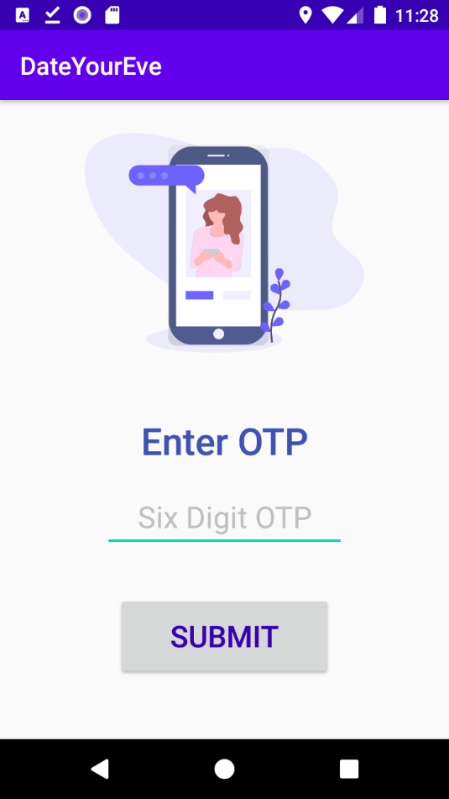

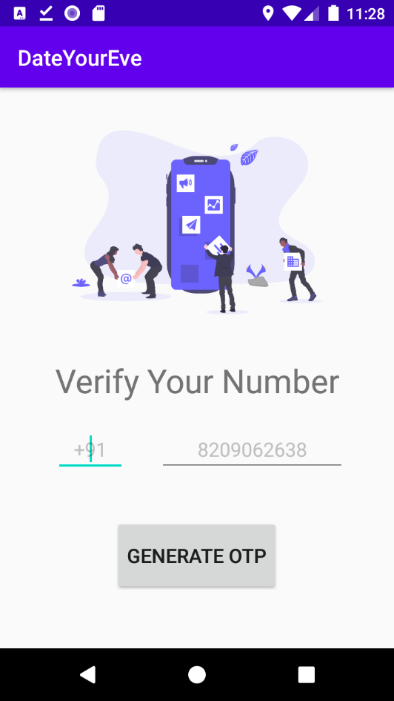

Figure 2: Login/OTP Screen

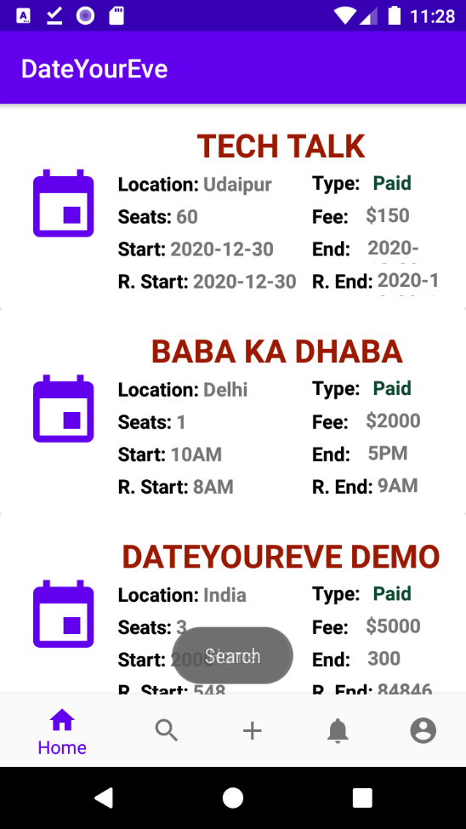

Figure 3: Home Module

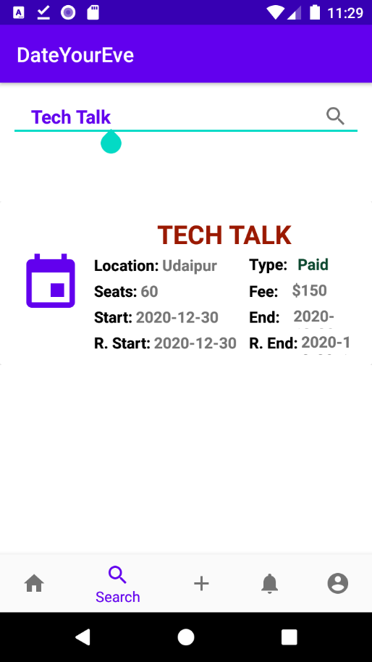

Figure 4: Search Module

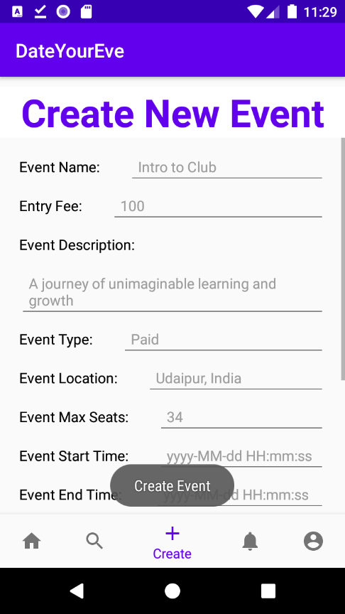

Figure 5: Create Event Module

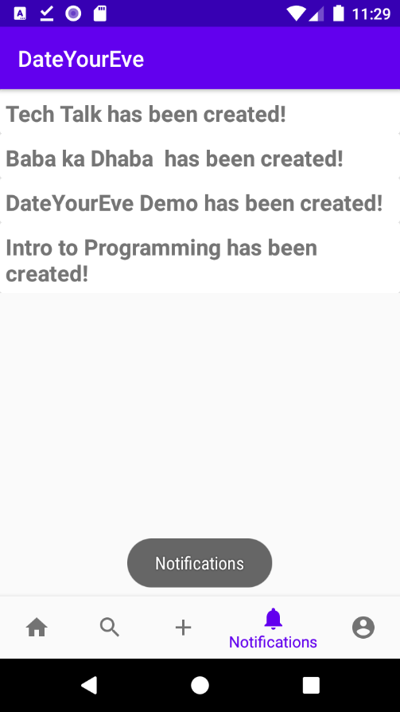

Figure 6: Notification Module

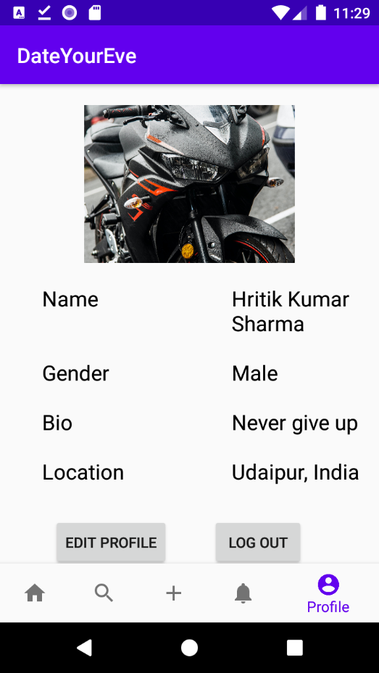

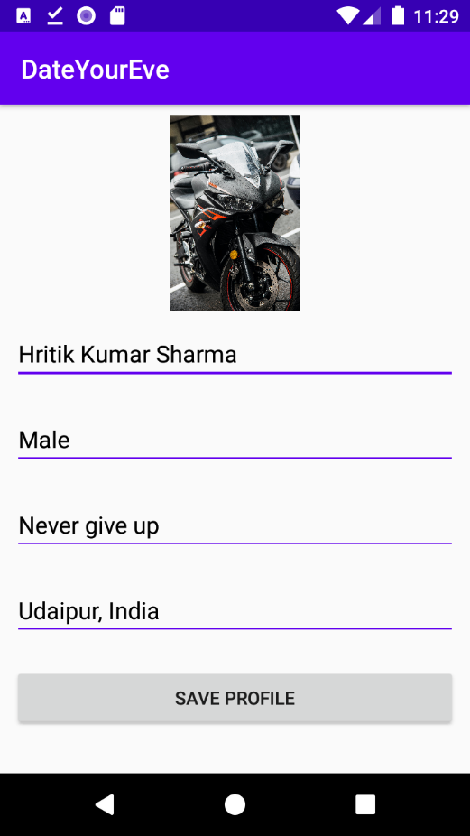

Figure 7: Profile Module

## Database Implementation

Database uses Firebase Firestore Database (NoSQL) consists of three collections of objects [3]:

* + - Events collection
    - Notifications collection of collections
    - Users collection

Objects of those collection are shown in figure below:

* Bio
* Gender
* Location
* Name
* ProfileImage

Users

* CreatedByUserId
* EntryFee
* EntryType
* EventDescription
* EventEndTime
* EventLocation
* EventMaxSeats
* EventName
* EventStartTime
* RegistrationStartTime

Events

* Eventid
* notification
* userId

Notifications

Figure 8: Internal Database Schema

## Coding Details

## 

Figure 9(a): Code Snippet of Login Screen

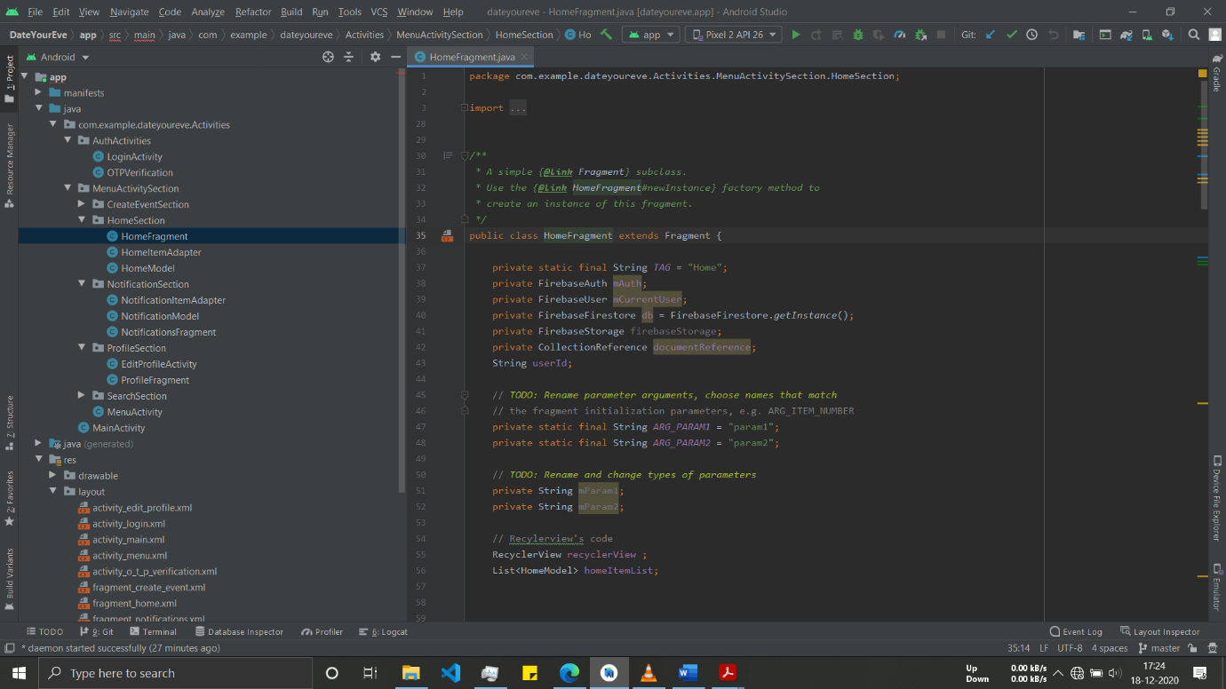

Figure 9(b): Code Snippet of Home Module

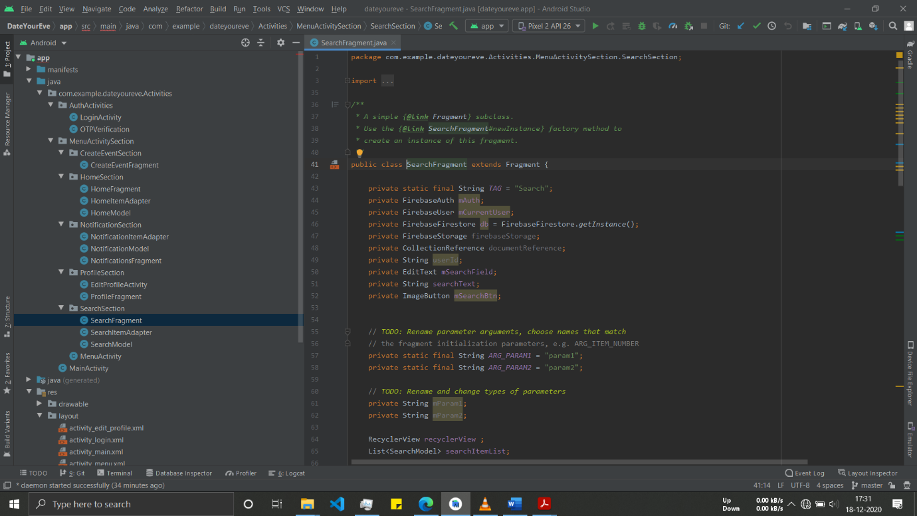

Figure 9(c): Code Snippet of Search Module

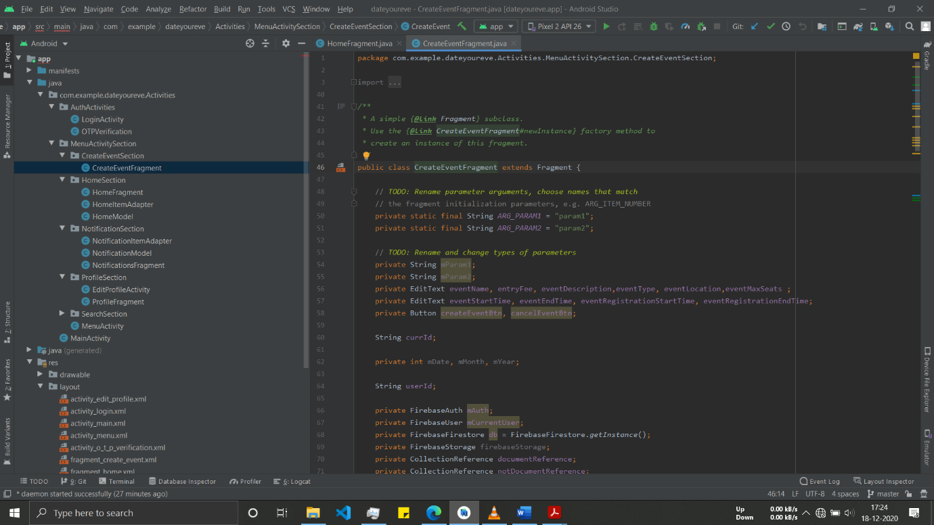

Figure 9(d): Code Snippet of Create Event Module

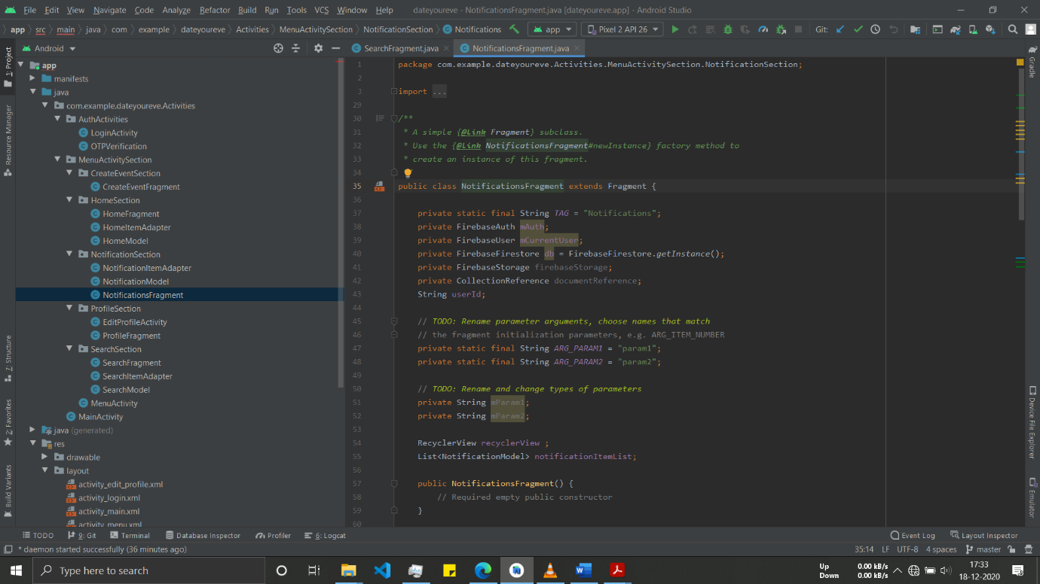

Figure 9(e): Code Snippet of Notifications Module

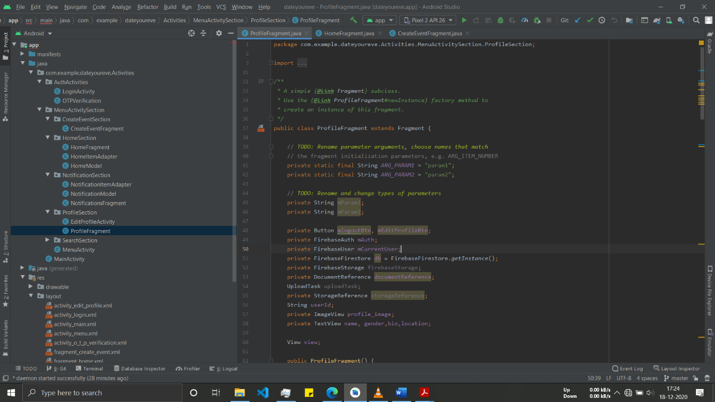

Figure 9(f): Code Snippet of Profile Module

## Testing

Testing of the software as a mean of accessing or measuring the software to determine its quality. The area of testing is one of the key process areas in ensuring the quality of the software known as Software Quality Assurance (SQA).

Testing is done with one primary objective to ensure the quality of the software before it is actually implemented. The main purpose of testing from developer’s point of view is to gain confidence. If no error is found at least he is sure that the product under development is meeting it required goals in terms of quality.

## Component Testing

Component testing is a method where testing of each component in an application is done separately.

Table 1: Component Testing

|  |  |  |
| --- | --- | --- |
| **Procedure** | **Pass/Fail** | **Actual Result** |
| Correct error message from properties file displays | Pass | Error message are displaying |
| Drop down boxes have correct values | Pass | All are correct |
| Have all items in all custom menus been tested? | Pass | All menu are functioning respectively |
| Ensure Proper usage of XML | Pass | Textbox controls the maximum number in corresponding fields |

## System Testing

Table 2: System Testing

|  |  |  |
| --- | --- | --- |
| Procedure | Pass/Fail | Actual Result |
| Handles posting functions correctly | Pass | All data are posted correctly |
| Does every field have the correct field label? | Pass | All field labelled correctly |
| Delete/Update and Insert | Pass | All data can be deleted/updated/inserted correctly |
| Handles editing functions correctly | Pass | All editing are functioning |

# CONCLUSION & FUTURE WORK

## Conclusion

Event Management System is actually a software which handle the essential data and save the data of the Event and its management. This software helps in effectively management of the events around us. We can also search the events around us. The application will also notify the user about the latest events happening around him.

The main purpose is effectively and easily handling of event data and its management.

**Future Work**

We can integrate extra features in this applications like Registration of Events by user, payment of Event, Deregistration of Event, Modification of Event, Attendees of Event can message with the organizer of the event, users' public profile on the application, feature of follow and comments, some extra third party support like google calendar integration, google meet and so on.

This application can also be improved on UI part though like redefining the home feed layout and search layout with more functionality which can be incorporated by Machine Learning & Artificial Intelligence

# References

1. [Add Firebase to your Android project (google.com)](https://firebase.google.com/docs/android/setup), Firebase Documentation
2. [Cloud Firestore  |  Firebase (google.com)](https://firebase.google.com/docs/firestore), Cloud Firestore Documentation
3. [Stack Overflow - Where Developers Learn, Share, & Build Careers](https://stackoverflow.com/), Stack Overflow
4. [GeeksforGeeks | A computer science portal for geeks](https://www.geeksforgeeks.org/), GeeksforGeeks